MRS EILEEN HUGHES
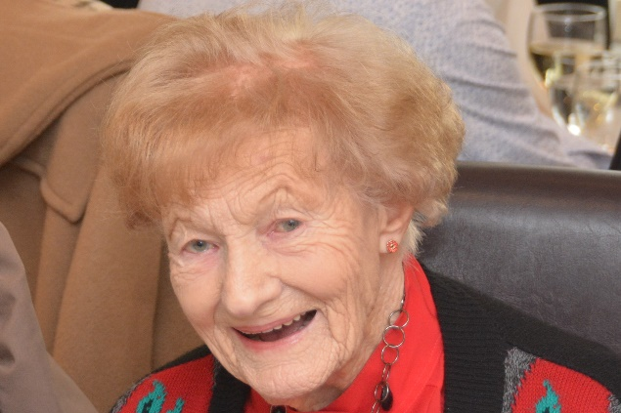
Eileen was born on 29th August 1921 at 73, West Side, Clapham Common, moving to Southend at the age of 8, when her Father, a musician, got a job in the Ballroom Orchestra at the Palace Hotel on the seafront. After about 2 years, the family, which included her brother Jack, who was 2 years younger than Eileen, moved back to Clapham before moving to Box Hill in Surrey when she was 13. Leaving school just before her 17th Birthday, she worked in an office in London, up to and after the London Blitz in 1941, when her office was evacuated to Bournemouth.
After a year there, Eileen and a friend volunteered for the A.T.S. (Auxiliary Territorial Service) and were posted to a gun site working instruments surrounding Heavy Anti-Aircraft guns, firstly near Liverpool and later Southampton. It was there that she met and fell in love with George and they were married at the end of the war in August 1945. She also inherited a stepson, George’s son Gordon, who was 10 years old when they married. They lived in a village called Broad Campden, near Chipping Campden in the beautiful Cotswolds and the family was completed by the births of their two daughters, Margaret in 1949 and Kathleen in 1951.
In 1962, after Gordon had married and left home, Eileen & George decided to move to Southend. The girls were at school and Eileen found office work, eventually becoming the wages clerk in Dixon’s Department store at Victoria Circus. She ended her working career back in the Civil Service, in the Customs and Excise Statistical Office in Victoria Avenue. During this time, both daughters had married and left home and she was devastated when George died in 1975.
After 5 years on her own, Eileen met and married Ron (a cousin by marriage) in 1980, acquiring a second step family; Angela, John and their 2 children. They made their home in Bonchurch Avenue, in Leigh spending 10 happy years there, enjoying holidays on the QE2 and Concorde, before Ron sadly died in 1990.
Ron (Hughes) was heavily involved with the Royal British Legion and it was his greatest wish that Eileen should join. She did so, firstly becoming Press Representative, and then Branch Secretary (a post she held for 15 years). By holding Garage sales, she helped the Branch regain solvency. She served as Poppy Appeal Organiser for several years, eventually retiring from active work and being appointed Branch President.
Her lifelong hobby has been choral singing, beginning with a school choir in Battersea at the age of 10, to being a founder member of the Southend Festival chorus for 33 years, then joining the new ladies choir, the Orpheus Singers. Coming from a musical family, she loved all kinds of music from 1930’s Dance Bands to classical concerts.
Eileen moved to Aragon Court in Hadleigh in 2007, and she passes the time making and selling marmalade, jam and chutney to her fellow residents in aid of charities, mainly the Poppy Appeal, but also to cancer charities after her beloved daughter Kathleen suffered and eventually died from ovarian cancer in 2012. This was a shattering blow for all the family, especially Eileen.
Another hobby that Eileen has is learning languages and she was delighted when the U3A opened in Hadleigh and immediately joined groups studying Italian and French. She also loves English and does a crossword every day as well as playing scrabble with friends.
Although not a good swimmer, Eileen loves the sea and takes every opportunity of going to the beach for a swim every summer. When she and her brother John were still in their teens, they hired a boat from Kingston and re-enacted the journey of 3 men in a boat, rowing up the Thames. Is was quite an adventure, especially as the Battle of Britain was going on overhead at the time.
Eileen will celebrate her 96th Birthday in August. When asked the secrets of living to such an age, Eileen usually say’s “Singing, Swimming and red wine (not necessarily in that order)”.
This research is courtesy of Bob O’Leary, Honorary Secretary of the Leigh-on-Sea Branch of the Royal British Legion.

