Your Name and Class

Name of the relative | Charlotte le Gallis
Relation to you | Great Aunt
Military Regiment / Service | New Zealand Army Nursing Corps
Home front location
Date of birth | 1881
Place of birth | North Island, New Zealand
Name of Husband or wife | Charles
Names of children | Charles and Anne
Rank | Sister
Service Number | 22137
Awards or medals | British War Medal, Victory Medal
Date of death | 1956
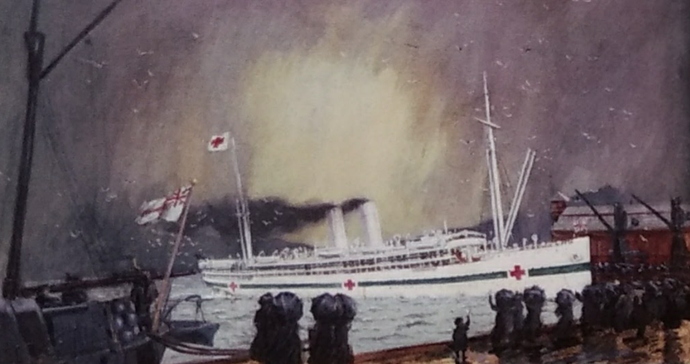
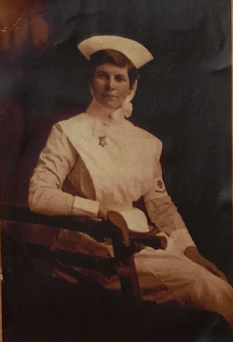
Photograph or image
Details of service
Lottie was on the nursing staff at Auckland Public Hospital when war broke our and was chosen in June 1915 to serve overseas. She was posted to the hospital ship Maheno which transported sick and wounded soldiers away from the Gallipoli peninsular. Sailing between Gallipoli and hospitals in Greece, Egypt, Malta and England, Lottie endured what she called ‘terrible clean ups’ while caring for the men wounded during the battle.
Lottie’s brother Leddie signed up for the army and wrote to the family on 3rd June 1915 – “Well, Dad I never thought that I would be a soldier, but now I am one, I am determined to be a good one. If I have bad luck, well I suppose it had to be.” Leddie was killed in action on 23rd July 1915. Lottie didn’t find out until November when her letters to her brother were returned and stamped “KILLED RETURN TO SENDER”

